***Final Project Report***

*4th Year 1st Semester Examination 2023*

***Course Code: CSE 410***

***Course Title :Mobile Application Development Laboratory*****

***Submitted to –***

***Dr. Md. Ezharul Islam***

*Professor*

*Department of Computer Science and Engineering*

*Jahangirnagar University*

***Anup Majumder***

*Assistant Professor*

*Department of Computer Science and Engineering*

*Jahangirnagar University*

***Samsun Nahar Khandakar***

*Lecturer*

*Department of Computer Science and Engineering*

*Jahangirnagar University*

***Submitted by -***

|  |  |  |
| --- | --- | --- |
| Name | Roll | Exam Roll |
| ***CHOYON SARKER*** | ***392*** | ***202204*** |
| ***SURAIYA MAHMUDA*** | ***364*** | ***202176*** |

***Department of Computer Science & Engineering***

*Jahangirnagar University*

*Savar, Dhaka-1342*

**Porte Chai (Tutor Finder App)**

**A Platform Connecting Students, Parents, and Tutors**

**Contents**

**1. Introduction . . . . . . . . . . . . . . . . . . . . . . . . . . . . . . . . ……….. 3**

**2. Intended Use . . . . . . . . . . . . . . . . . . . . . . . . . ………….…... . . 3**

**2.1 For Parents . . . . . . . . . . . . . . . . . . . . . . . . . ………….…... . . 3**

**2.2 For Students . . . . . . . . . . . . . . . . . . . . . . . . . ……………... . . 4**

**2.3 For Tutors . . . . . .... . . . . . . . . . . . . . . . . . . . ………….…... . . 4**

**3. Operating Environment . . . . . …. . ... . . . . . . ……………... . . 4**

**4. App Demonstration…………………………………………….. 5**

**4.1 Opening Splash Screen . . . . . . . . . . . . . . . . . . . . . . . . . …….. . 5**

**4.2 Login and Registration Page and Rest Pages . .. . .. . . . (6-27)**

**5. Technical Approach . . . . . . . . . . . . . . . . . . . . . …………..... . . 28**

**6. Conclusions . . . . . . . . . . . . . . . . . . . . . . . . . . . ………….... . . . . 29**

**7. Future Prospects of Our Work . . . . . . . . . . . . ….. . . . . . . . . . . 29**

**1. Introduction**

**Porte Chai** is a mobile application designed to seamlessly connect students, parents, and tutors. It offers an efficient and user-friendly platform where parents can find qualified tutors for their children, students can find teachers for themselves, and tutors can discover teaching opportunities. By integrating robust features such as job posting, browsing, communication, and application management, **Porte Chai** aims to simplify and enhance the tutoring experience.

**2. Intended Use**The **Porte Chai** app is designed to serve as a comprehensive platform that bridges the gap between individuals seeking tutoring services and qualified tutors. Its intended use spans across various user roles—parents, students, and tutors—ensuring each user can achieve their educational or professional goals effectively.

### ****2.1 For Parents****

Parents can use **Porte Chai** to find reliable and skilled tutors for their children. The app provides tools for:

* **Posting Job Offers:** Parents can create detailed job postings, specifying subjects, grade levels, schedules, location preferences, and any additional requirements.
* **Reviewing Applications:** Easily review tutor profiles and qualifications to select the best match for their child’s needs.
* **Managing Posts and Communication:** Modify, delete, or manage job posts and interact directly with tutors through in-app messaging.
* **Building Trust:** Utilize ratings and reviews to identify highly recommended tutors and ensure a trustworthy learning environment for their children.

### ****2.2 For Students****

Students seeking academic guidance can directly interact with tutors for their specific needs. They can:

* **Post Requirements:** Similar to parents, students can post job opportunities to attract tutors specialized in their area of study.
* **Search for Tutors:** Browse tutor profiles and job applications to find the best fit.
* **Communicate with Tutors:** Contact tutors through the app for clarifications, scheduling, or inquiries.
* **Track and Manage Applications:** Keep a record of posts and received applications for better management.

### ****2.3 For Tutors****

Tutors looking for teaching opportunities can use the app to grow their client base and expand their expertise. Key functionalities include:

* **Finding Jobs:** Browse and filter tutoring jobs based on location, Post Title that match their preferences.
* **Applying for Positions:** Submit detailed applications, including qualifications, resumes directly through the app.
* **Building Credibility:** Use the rating and review system to establish trust and attract more clients.
* **Managing Applications:** Track the status of submitted applications and respond promptly to job posters.

### 3. Operating Environment

### ****Platform****

* **Target Platform:** Android (Mobile Devices and Tablets)
* **Supported Android Versions:** Android 8.0 (Oreo) and above, ensuring compatibility with a wide range of devices.
* **Distribution Platform:** Available on the Google Play Store for users to download and install.
* **Device Compatibility:** Optimized for devices with 2 GB or more of RAM and a screen resolution of 720p or higher.

### ****Development****

* **Programming Language:** Kotlin, chosen for its modern features and seamless integration with Android development.
* **Integrated Development Environment (IDE):** Android Studio, providing tools for efficient coding, design, and debugging.
* **Backend Services:** Powered by Firebase for scalability and reliability:
  + **Authentication:** Secure user login and sign-up options.
  + **Firebase Database:** Real-time and scalable storage for posts, profiles, and messages.
  + **Cloud Functions:** Handling server-side operations like notifications and data processing.
  + **Cloud Messaging:** Real-time notifications for user interactions and updates.
* **Testing Frameworks:** JUnit for unit testing and Firebase Test Lab for compatibility testing across multiple devices.
* **Version Control:** Managed using Git for source code tracking and collaboration.

### 4. App demonstration

***4.1 Opening Splash screen***



***4.2 Login and Registration page***



***4.3 Complete Registration Page:***

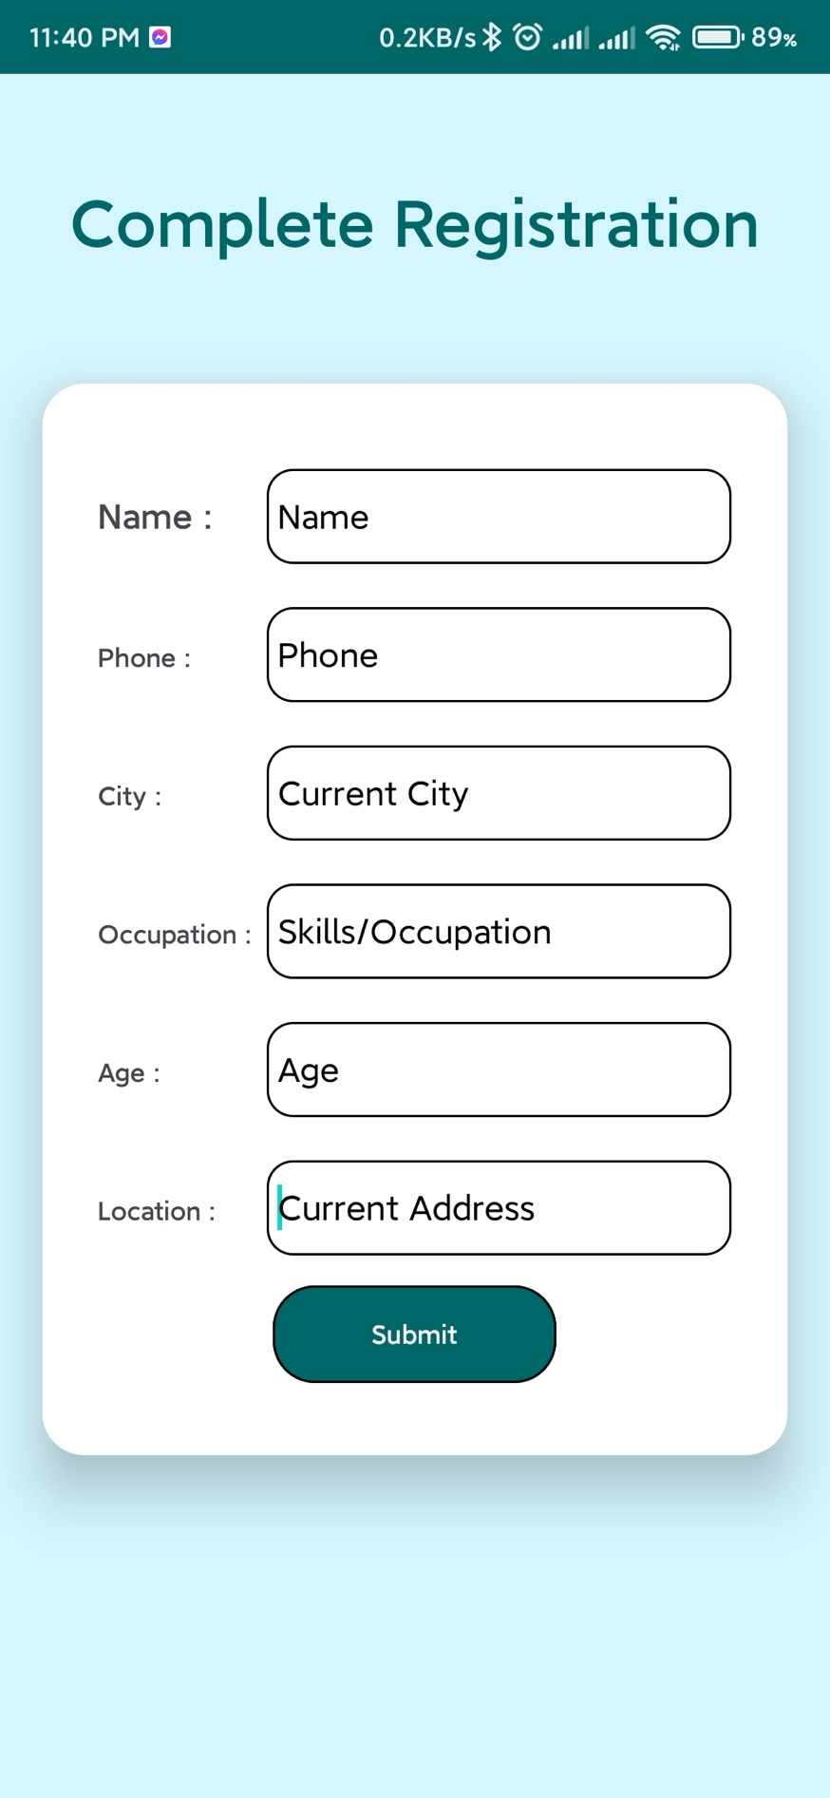

***4.4 Reset Password***

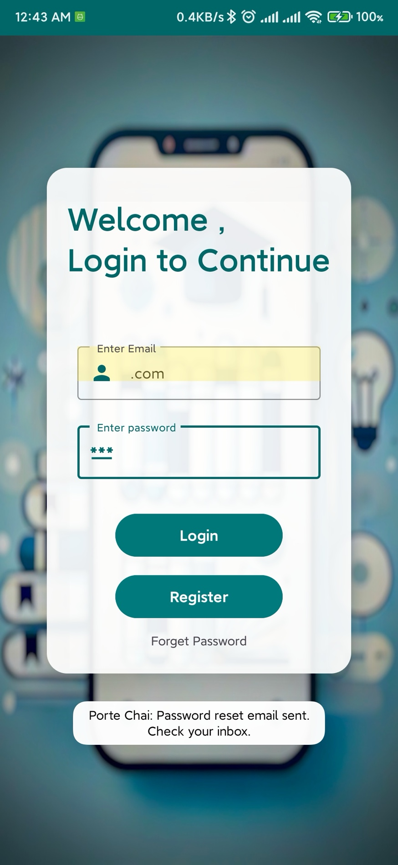

***4.5 Reset Password via Email***

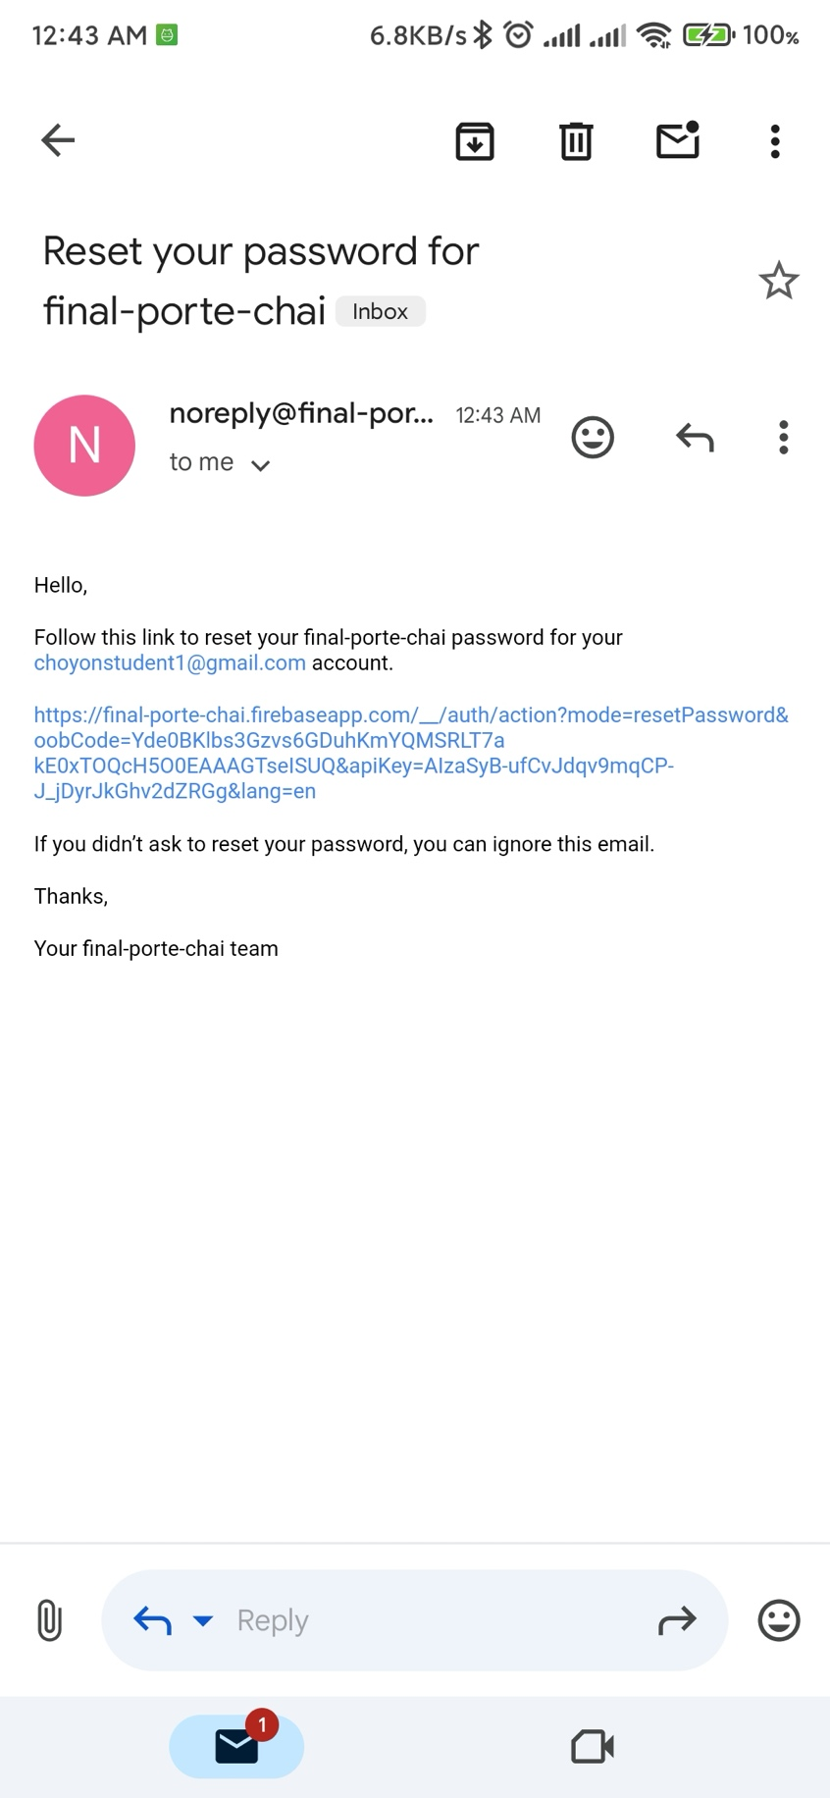

***4.6 Enter New password***



***4.7 Updated password***



***4.8 Home Page***

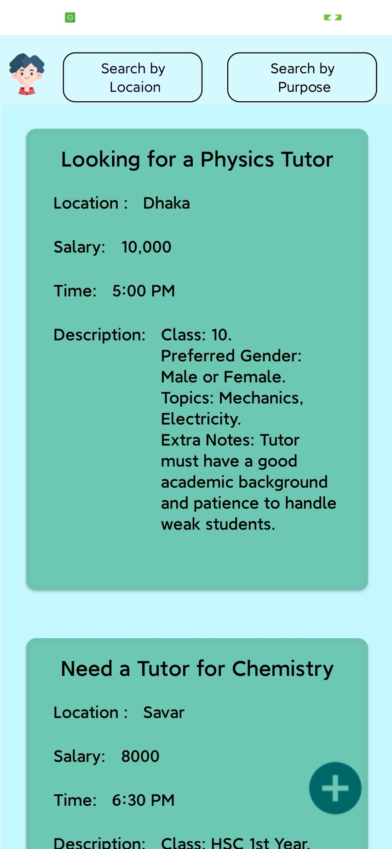

***4.9 Search By Post Purpose***

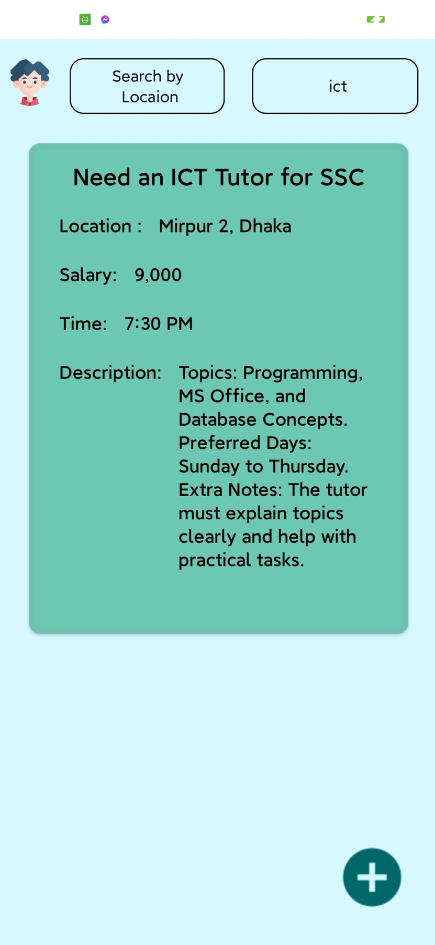

***4.10 Search By Location or Area***

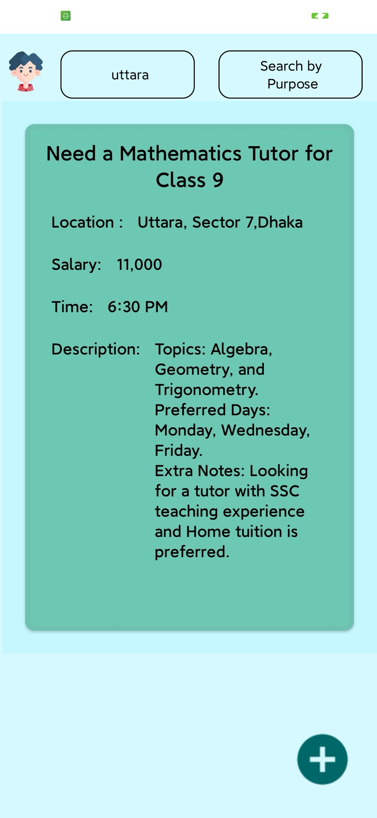

***4.11 Student Dashboard***

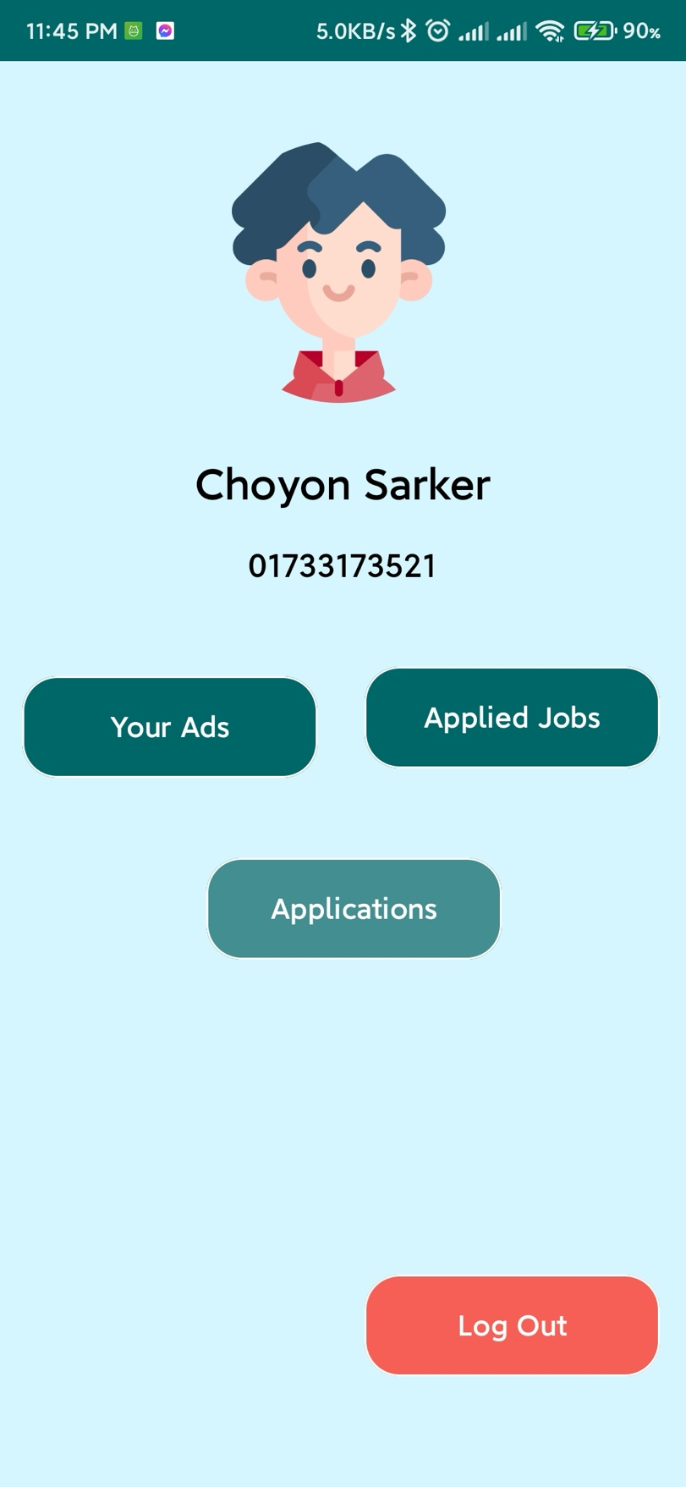

***4.12 Student Profile Section***

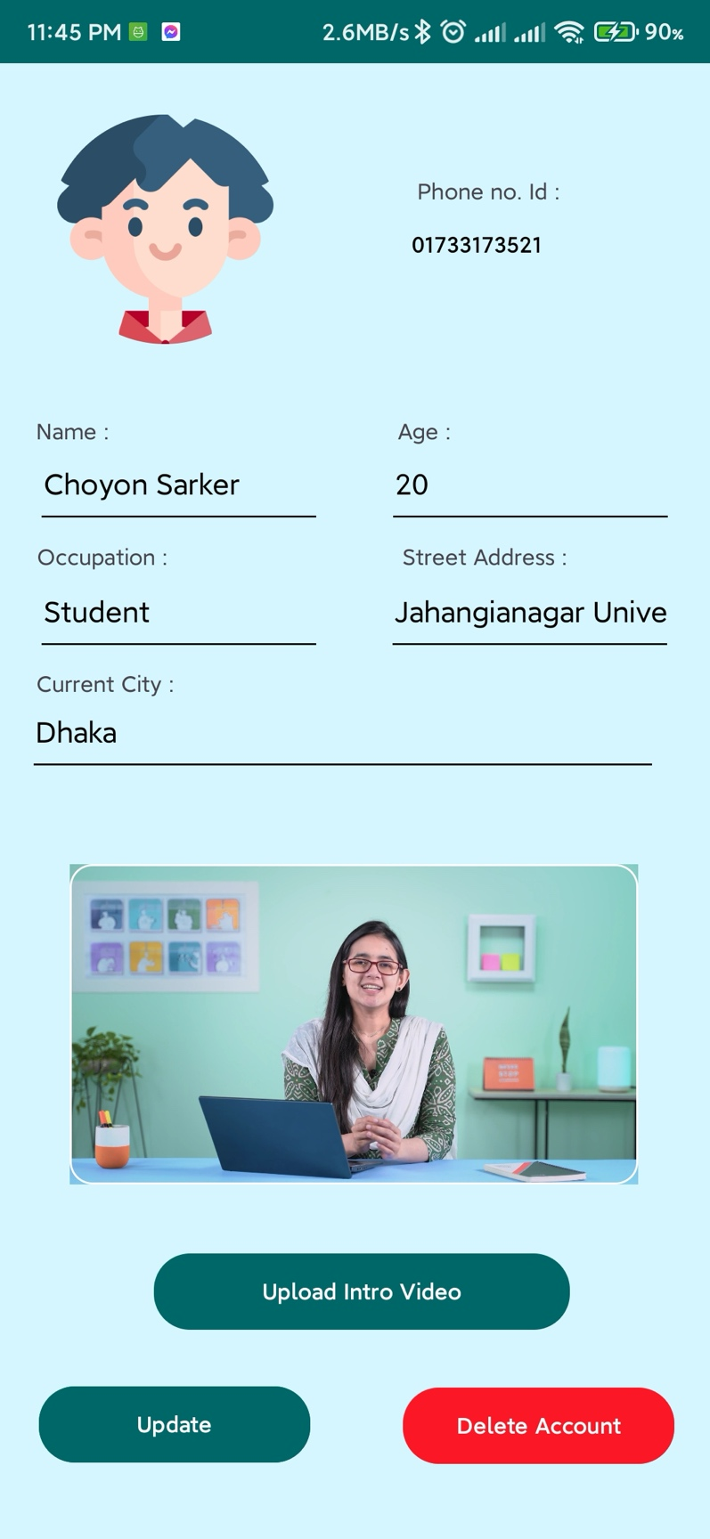

***4.13 Select Student Profile Picture by gender and catagories***

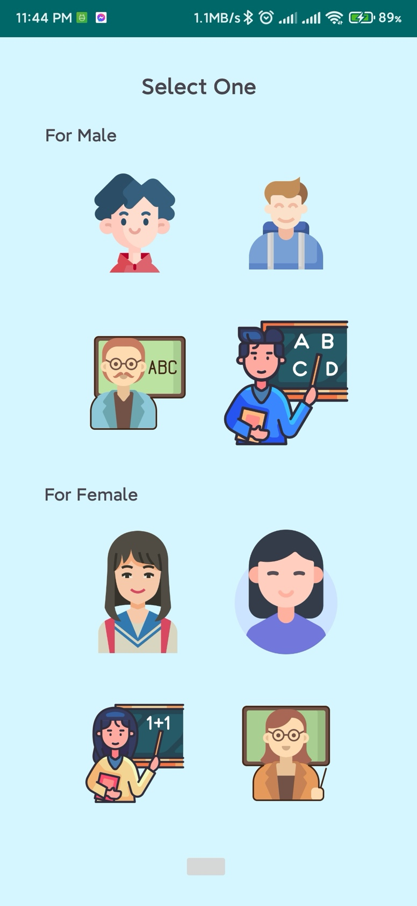

***4.14 Update Student Profile Picture***

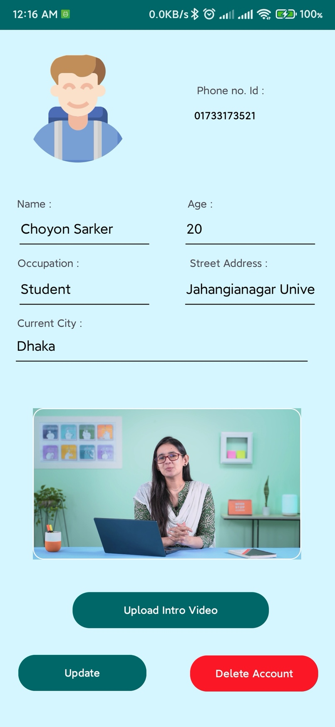

***4.15 Update Student Profile information and Change Introduction Video***

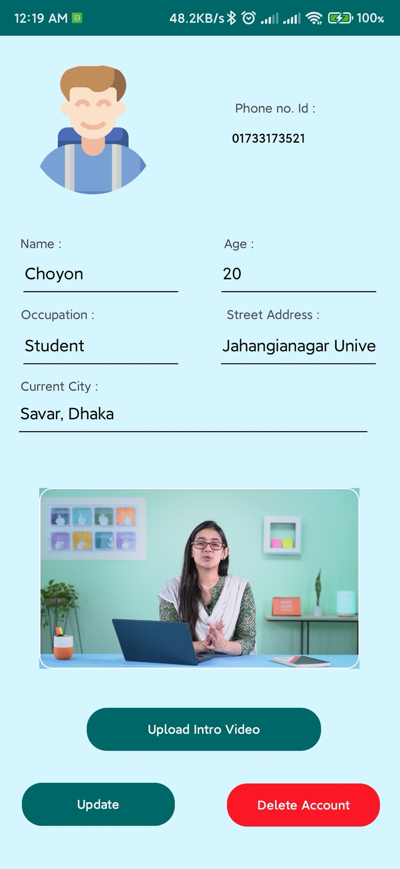

***4.16 Change introductory video and select from your local files***

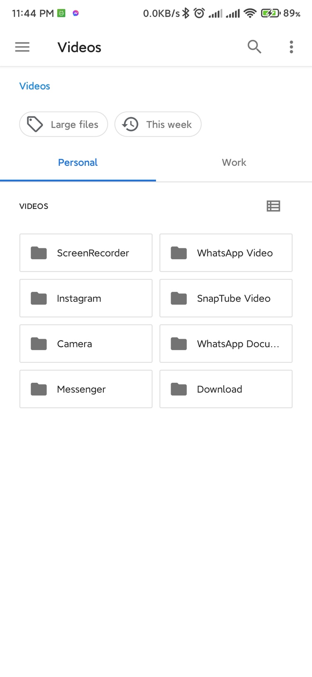

***4.17 Student Dashboard’s Your adds section***

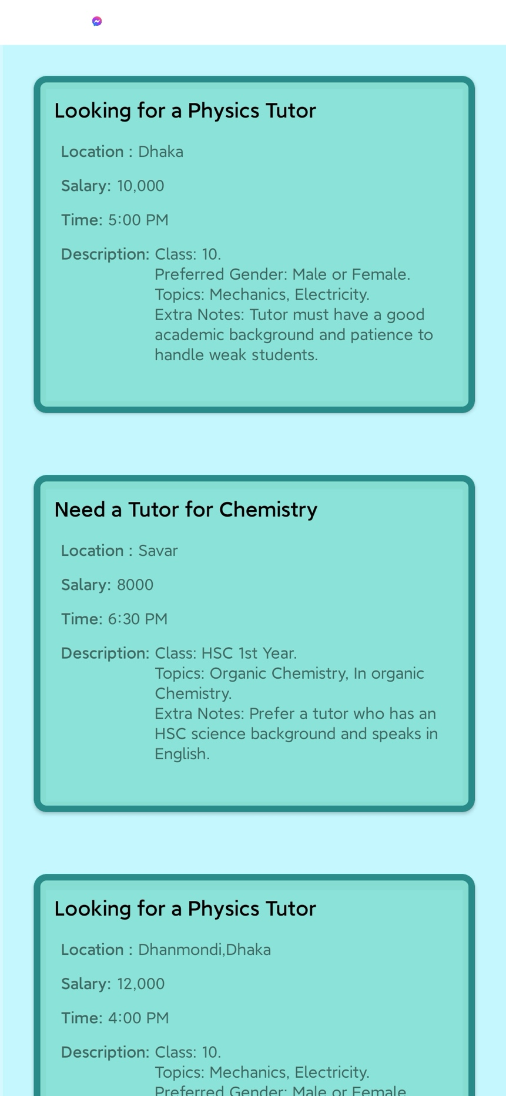

***4.18 Student Dashboard’s Application Section***

**

***4.19 Student can call Teacher who applied for his post***

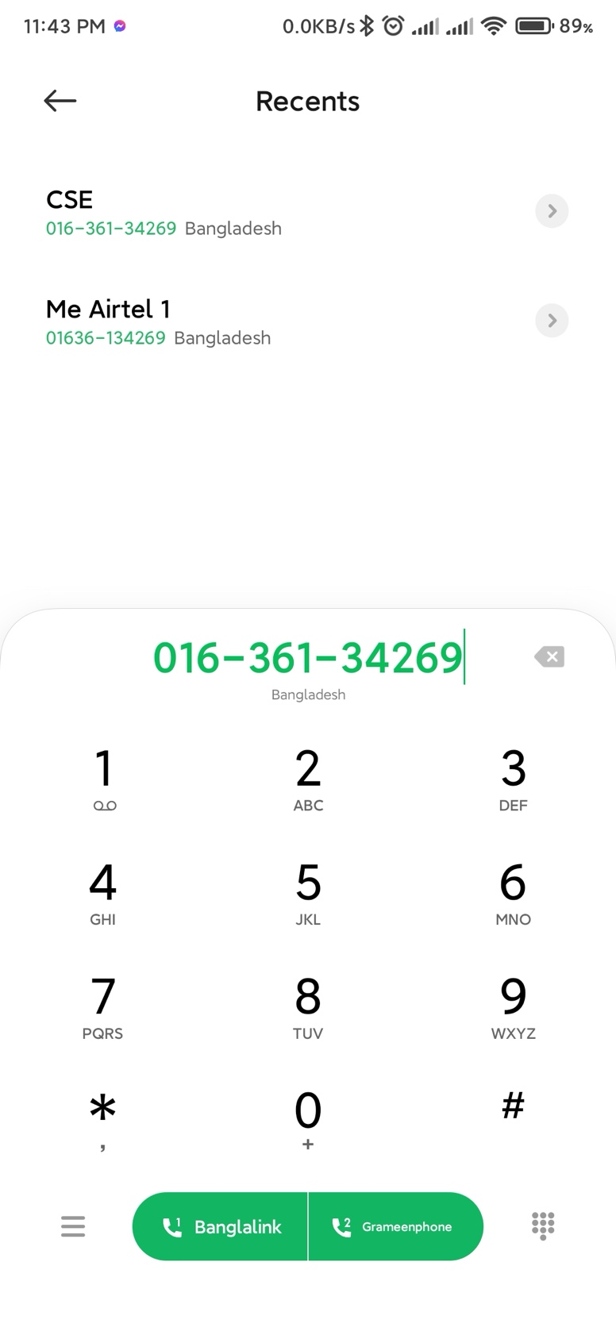

***4.20 Teacher’s Dashboard***

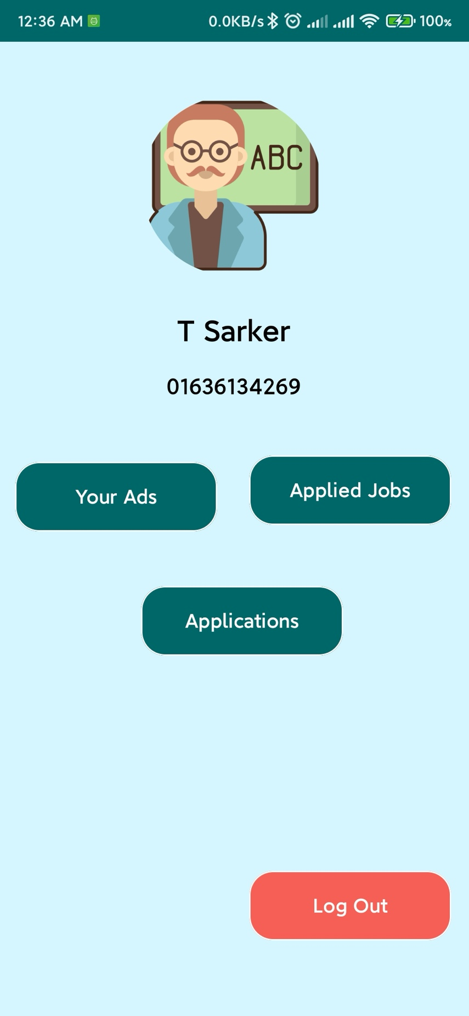

***4.21 Teacher Dashboard’s Your add section***

**

***4.22 Teacher Apply Students Post can be send his cv***

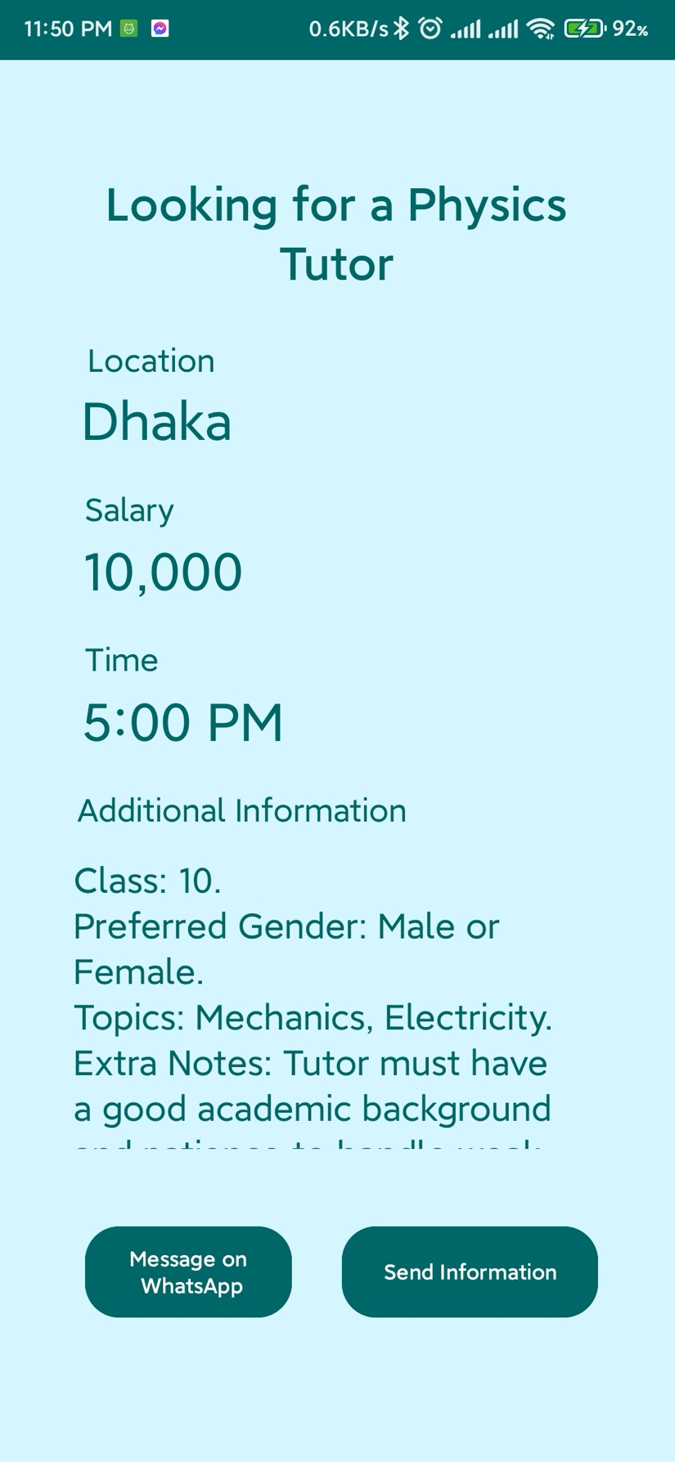

***4.23 Can also chat with the post creator through Whatsapp***

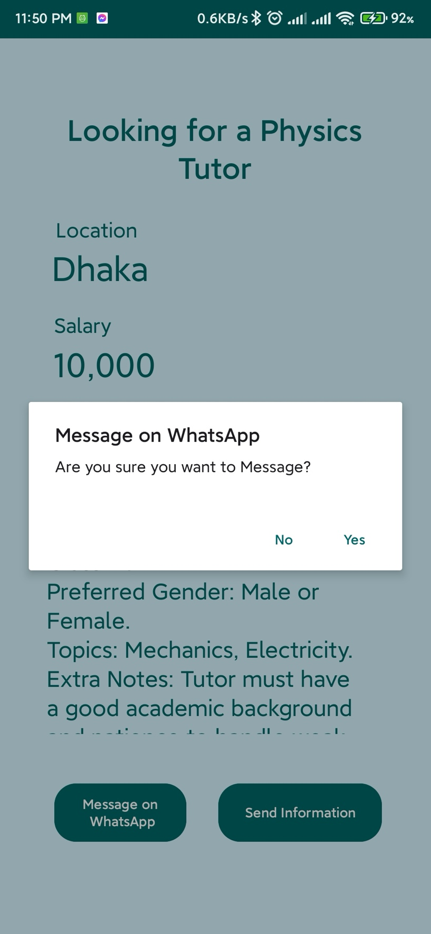

**5.** Technical Approach

#### ****Front-End Development****

* **User Interface:**
  + Designed using XML layouts in Android Studio to create a modern, visually appealing, and user-friendly interface.
  + Prioritizes intuitive navigation, making it easy for users to access features like posting jobs, browsing profiles, and managing applications.
* **Development Framework:**
  + Built using Java , a modern programming language for Android development, ensuring app responsiveness, maintainability, and enhanced performance.

#### ****Back-End Development****

* **Database Management:**
  + **Firebase Firestore** is utilized for real-time data storage and synchronization.
  + Stores user data such as profiles, job posts, applications, and messages securely and efficiently.
* **Server-Side Logic:**
  + Implements Firebase Cloud Functions to handle core operations like:
    - Creating and managing job posts.
    - Tracking applications and their statuses.
    - Facilitating user communication.
* **Push Notifications:**
  + **Firebase Cloud Messaging (FCM):** Provides real-time alerts for new job posts, received applications, and important updates, ensuring users are always informed.

### 6. Conclusion

**Porte Chai** revolutionizes the way parents, students, and tutors connect, offering a comprehensive platform for finding and managing tutoring opportunities. By integrating advanced features such as job posting, application tracking, and in-app communication, the app provides an efficient and reliable experience for its users. With a focus on user satisfaction and trust, **Porte Chai** aims to become a leading platform in the tutoring ecosystem.

**7. Future Prospects of Our Work**

1. Expanding to include online tutoring options.
2. Integrating payment systems for seamless transactions.
3. AI-based tutor recommendations.
4. Multilingual support for diverse regions.